**New feature angular > 16**

**Standalone**



**Imports**

Standalone components can import other standalone components, directives, and pipes as well as existing NgModules.

**HttpClientModule**

HttpClientModule has been deprecated and replaced with a simpler, more efficient method for setting up HTTP services, using function provideHttpClient()

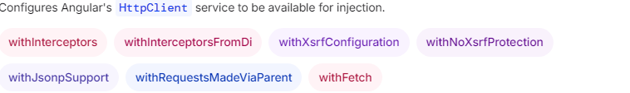

* providers: [provideHttpClient()]
* providers: [

provideHttpClient(

withInterceptors([loggingInterceptor]),

)

],

* providers: [

provideHttpClient(

withInterceptorsFromDi()

),

{ provide: HTTP_INTERCEPTORS, useClass: LoggingInterceptor, multi: true }

]

**Signals**

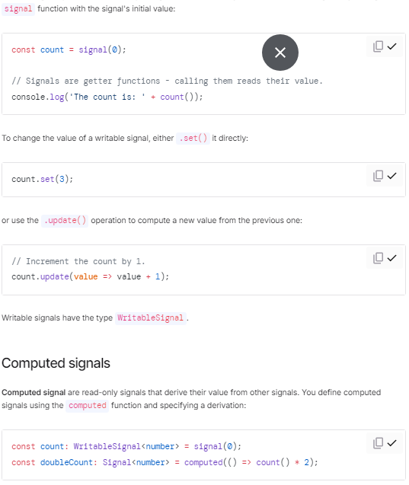

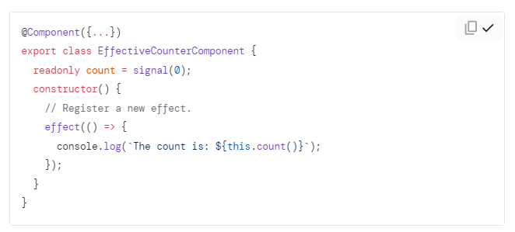

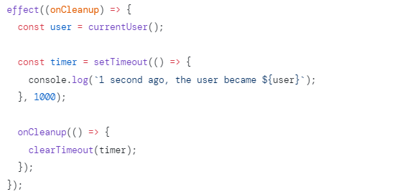

**@if** -*ngIf **@else**

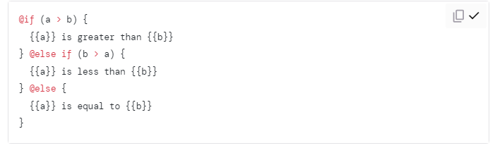

**@for** -*ngFor

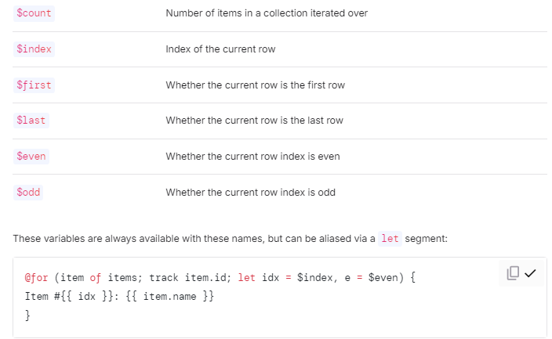

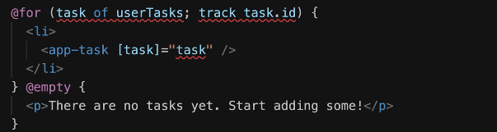

**@switch -\*** ngSwitch

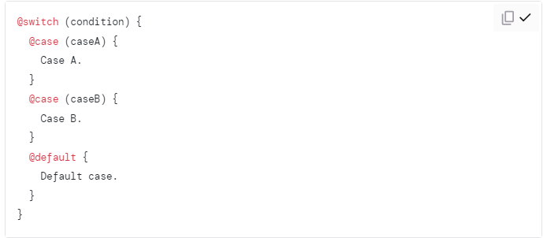

**@defer**

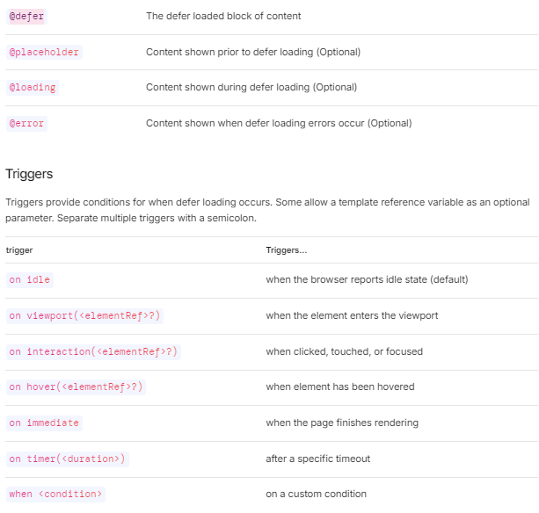

**@defer** ( on <trigger>; when <condition>; prefetch on <trigger>; prefetch when <condition> )

{ <!-- deferred template fragment --> <calendar-cmp />}

**@placeholder** ( minimum? <duration> )

{ <!-- placeholder template fragment --> <p>Placeholder</p>}

**@loading** ( minimum? <duration>; after? <duration> )

{ <!-- loading template fragment --> <img alt="loading image" src="loading.gif" />}

**@error** { <!-- error template fragment --> <p>An loading error occurred</p>}

**New hooks**

afterRender and afterNextRender

**afterRender**: allows you to register a callback that executes after every render cycle.

**afterNextRender**: registers a callback that executes ONLY ONCE after the next render cycle, when the DOM is loaded.

**DestroyRef**

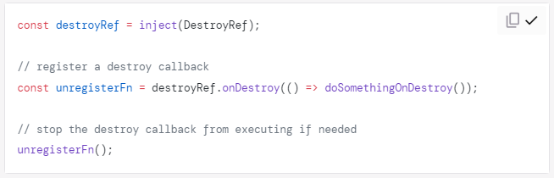

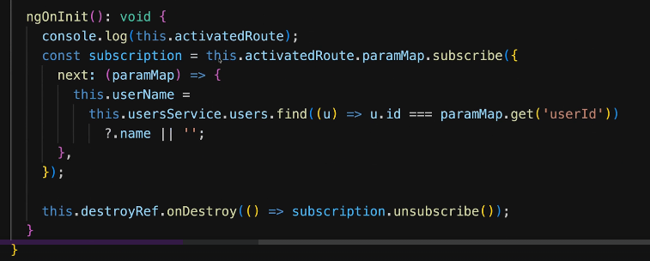

**Main.ts change**

**Previously**

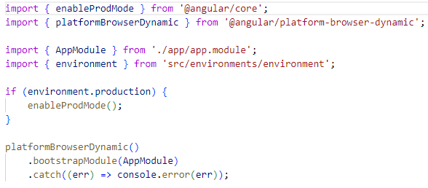

**Updated**

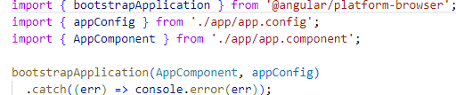

**Routing**

**Previously**

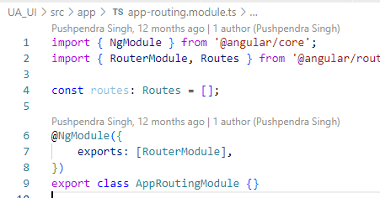

**Updated**

